SOAP Aunthetication in web services

namespace AuthForWebServices

{

/// <summary>

/// Summary description for WebService

/// </summary>

[WebService(Namespace = "http://tempuri.org/")]

[WebServiceBinding(ConformsTo = WsiProfiles.BasicProfile1_1)]

[System.ComponentModel.ToolboxItem(false)]

// To allow this Web Service to be called from script, using ASP.NET AJAX, uncomment the following line.

[System.Web.Script.Services.ScriptService]

public class WebService : System.Web.Services.WebService

{

public AuthHeader Authentication;

public WebService()

{

InitializeComponent();

}

private IContainer components = null;

private void InitializeComponent()

{

}

protected override void Dispose(bool disposing)

{

if (disposing && components != null)

{

components.Dispose();

}

base.Dispose(disposing);

}

[SoapHeader("Authentication", Required = true)]

[WebMethod(Description = "Returns some sample data")]

public string SensitiveData()

{

string data = null;

if (Authentication.Username == "test" && Authentication.Password == "test")

{

data = "Success";

}

else

{

data = "Error";

}

return data;

}

}

public class AuthHeader : SoapHeader

{

public string Username {get;set;}

public string Password {get;set;}

}

}

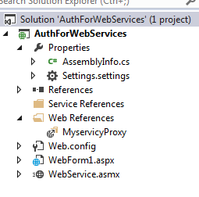

Add Web Refrence of the webservice to the conjumning Project

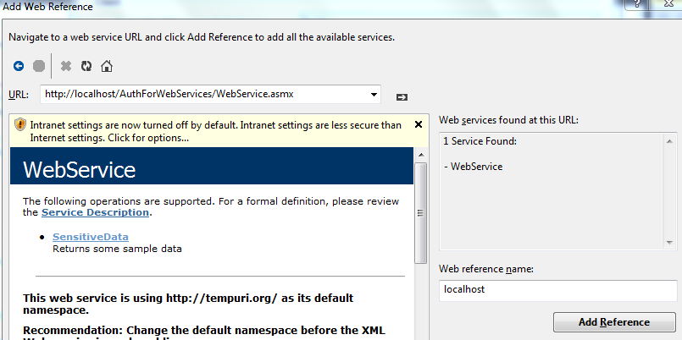

using System;

using System.Collections.Generic;

using System.Linq;

using System.Web;

using System.Web.UI;

using System.Web.UI.WebControls;

using AuthForWebServices.MyservicyProxy;

namespace AuthForWebServices

{

public partial class WebForm1 : System.Web.UI.Page

{

protected void Page_Load(object sender, EventArgs e)

{

}

protected void Button1_Click(object sender, EventArgs e)

{

AuthForWebServices.MyservicyProxy.WebService webService = new MyservicyProxy.WebService();

AuthForWebServices.MyservicyProxy.AuthHeader authentication = new MyservicyProxy.AuthHeader();

authentication.Username = "test111";

authentication.Password = "test111";

webService.**AuthHeaderValue** = authentication;

string data = webService.SensitiveData();

var fgg = data;

}

}

}

